

Capital University of Science & Technology (CUST)

**SEMESTER PROJECT**

**DEPARTMENT OF:** SOFTWARE ENGINEERING

**NAME:** RANA HAMMAD MUSHTAQ

**REG NO:** BSE233041

**GROUP MEMBERS:**

1. MUHAMMAD KHAN -(BSE233019)
2. MUHAMMAD ABDULLAH KHALID-(BSE233051)
3. MUHAMMAD ASIF-(BSE233078)

**DATE:** 18-1-2025

**SECTION:** 2

**COURSE:** INTRO TO DATABASE SYSTEM

**TOPIC:** ONLINE BOOKSTORE DATABASE

**SUMBITTIED TO:** MAAM HINA RASHID

**GITHUBLINK:** https://github.com/RanaHammadMushtaq

Contents

1. Database Planning 2

2. System Definition 2

3. Requirements Collection and Analysis 3

4. Database Design 3

Entities and Attributes: 3

Relationships: 4

ER DIAGRAM: 4

NORMALIZATION 4

FIRST NORMAL FORM: 5

Tables in 2NF: 5

Third Normal Form (3NF) 6

5. DBMS Selection 6

6. Application Design 6

Interfaces Designed: 7

Functional Components: 7

7. Prototyping (Optional) 7

8. Implementation 10

Tools Used: 10

Steps Taken: 10

9. Data Conversion and Loading 10

PHPMYADMIN 10

SQL QUERIES 11

10. Testing 12

11. Operational Maintenance 12

**ONLINE BOOKSTORE DATABASE PROJECT**

**Database Lifecycle for Online Bookstore**

This document outlines the complete database lifecycle for the Online Bookstore project, following the standard phases of database development. The system supports login/registration, browsing books, managing a cart, placing orders, and confirming orders.

# ****1. Database Planning****

**Purpose:**  
To create a scalable and efficient database for managing user accounts, book inventory, and order processing for the Online Bookstore.

**Objectives:**

* Ensure seamless user account management.
* Facilitate efficient book inventory tracking.
* Support order lifecycle from cart to confirmation.

**Identified Entities:**

1. **User** - Represents customers.
2. **Book** - Stores information about books.
3. **Order** - Captures order details.
4. **Order_Item** - Tracks items within an order.

**Relationships:**

* A user can place multiple orders.
* Each order can include multiple books.

# ****2. System Definition****

**System Scope:**  
The Online Bookstore manages:

* **Login/Registration:** Secure user access.
* **Book Browsing:** Displaying available books.
* **Cart Management:** Allow users to add/remove books from their cart.
* **Order Formation:** Capturing cart details as an order.
* **Order Confirmation:** Generating and storing order details.

**Target Users:**

1. Customers: End-users of the bookstore.
2. Administrators: Manage inventory and process orders.

**System Purpose:**  
To deliver an efficient and user-friendly platform for online book shopping.

# ****3. Requirements Collection and Analysis****

**Fact-Finding Techniques:**

1. **Interviews:** With potential users to understand expectations.
2. **Surveys:** Collected feedback on key features.
3. **Analysis:** Reviewed existing systems for inspiration.

**Key Insights:**

* A streamlined book display and ordering process is crucial.
* The cart feature must allow users to modify selections before checkout.

# ****4. Database Design****

### ****Entities and Attributes:****

1. **User**:
   * User_ID (Primary Key)
   * Name
   * Email
   * Password
2. **Book**:
   * Book_ID (Primary Key)
   * Title
   * Author
   * Genre
   * Price
   * Stock_Quantity
3. **Order**:
   * Order_ID (Primary Key)
   * User_ID (Foreign Key)
   * Order_Date
4. **Order_Item**:
   * Order_Item_ID (Primary Key)
   * Order_ID (Foreign Key)
   * Book_ID (Foreign Key)
   * Quantity
   * Price

### ****Relationships:****

1. **User - Order:** One user can place multiple orders.
2. **Order - Order_Item:** One order can have multiple items.
3. **Order_Item - Book:** Each item references a single book.
4. **User-**Book: One user can but multiple books.

## ****ER DIAGRAM:****

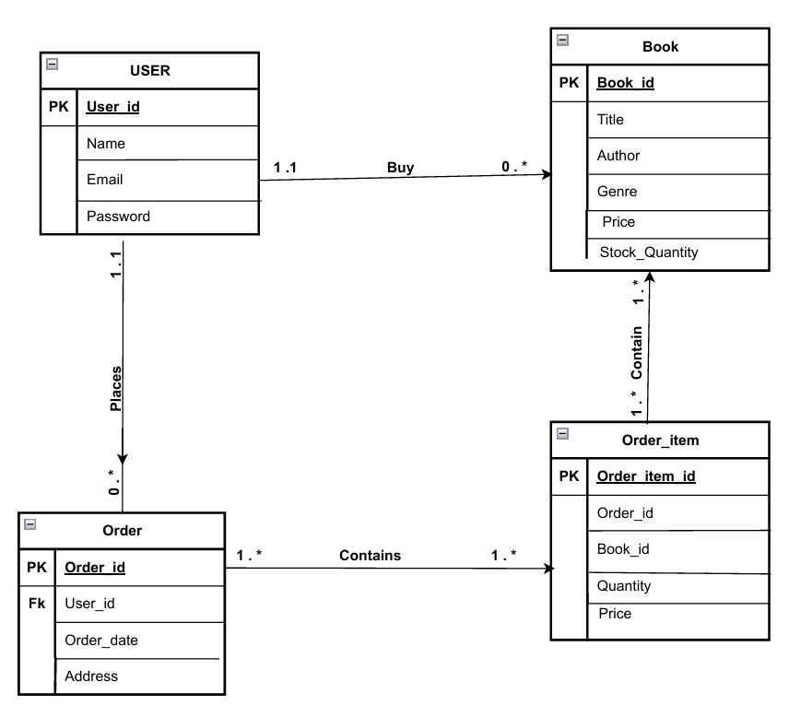

## ****NORMALIZATION****

### ****FIRST NORMAL FORM:****

| **Order_ID** | **User_ID** | **User_Name** | **Email** | **Password** | **Book_ID** | **Title** | **Author** | **Genre** | **Price** | **Quantity** | **Stock_Quantity** |  |
| --- | --- | --- | --- | --- | --- | --- | --- | --- | --- | --- | --- | --- |

|  |  |  |  |  |  |  |  |  |  |  |  |  |
| --- | --- | --- | --- | --- | --- | --- | --- | --- | --- | --- | --- | --- |
| 1 | 101 | Rana | rana@gmail.com | pass123 | 0 | 1984 | George Orwell | Dystopian | 599.00 | 2 | 30 |  |

|  |  |  |  |  |  |  |  |  |  |  |  |  |
| --- | --- | --- | --- | --- | --- | --- | --- | --- | --- | --- | --- | --- |
| 1 | 101 | Rana | rana@gmail.com | pass123 | 3 | Harry Potter and the Sorcerer's Stone | J.K. Rowling | Fantasy | 4797.00 | 1 | 200 |  |

|  |  |  |  |  |  |  |  |  |  |  |  |  |
| --- | --- | --- | --- | --- | --- | --- | --- | --- | --- | --- | --- | --- |
| 2 | 102 | khan | khan@gmail.com | pass456 | 6 | The Da Vinci Code | Dan Brown | Mystery | 6897.00 | 3 | 80 |  |

|  |  |  |  |  |  |  |  |  |  |  |  |  |
| --- | --- | --- | --- | --- | --- | --- | --- | --- | --- | --- | --- | --- |
| 3 | 101 | rana | rana@gmail.com | pass123 | 7 | Mastering the Art of French Cooking | Julia Child | Cooking | 6997.00 | 1 | 40 |  |

### Tables in 2NF:

1. **User Table**:

| **User_ID** | **Name** | **Email** | **Password** |
| --- | --- | --- | --- |
| 101 | Rana | rana@gmail.com | pass123 |
| 102 | khan | khan@gmail.com | pass456 |

1. **Book Table**:

| **Book_ID** | **Title** | **Author** | **Genre** | **Price** | **Stock_Quantity** | **Image_URL** |
| --- | --- | --- | --- | --- | --- | --- |
| 0 | 1984 | George Orwell | Dystopian | 599.00 | 30 | Images url here |
| 3 | Harry Potter and the Sorcerer's Stone | J.K. Rowling | Fantasy | 4797.00 | 200 | Images url here |
| 6 | The Da Vinci Code | Dan Brown | Mystery | 6897.00 | 80 | Images url here |
| 7 | Mastering the Art of French Cooking | Julia Child | Cooking | 6997.00 | 40 | Images url here |

1. **Order Table**:

| **Order_ID** | **User_ID** | **Order_Date** |
| --- | --- | --- |
| 1 | 101 | 2025-01-18 |
| 2 | 102 | 2025-01-19 |
| 3 | 101 | 2025-01-20 |

1. **Order_Item Table**:

| **Order_Item_ID** | **Order_ID** | **Book_ID** | **Quantity** | **Price** |
| --- | --- | --- | --- | --- |
| 1 | 1 | 0 | 2 | 599.00 |
| 2 | 1 | 3 | 1 | 4797.00 |
| 3 | 2 | 6 | 3 | 6897.00 |
| 4 | 3 | 7 | 1 | 6997.00 |

### Third Normal Form (3NF)

* Remove transitive dependencies (ensure non-key attributes depend only on the primary key).

**Tables in 3NF** (No Changes):

* All tables already meet 3NF conditions. Attributes like User_Name, Email, and Password depend only on User_ID, and Title, Author, Genre, etc., depend only on Book_ID.

# ****5. DBMS Selection****

**Chosen DBMS:**  
MySQL was selected for its support for relational databases, ease of use, and scalability. It ensures data consistency and performance.

# ****6. Application Design****

### ****Interfaces Designed:****

1. **Login/Registration Page:** Users can create accounts or log in.
2. **Home Page:** Displays a welcome message and links to the book page.
3. **Book Page:** Lists all books with title, price, and stock details.
4. **Cart Page:** Allows users to view, add, or remove items.
5. **Order Formation Page:** Captures the final cart details.
6. **Order Confirmation Page:** Confirms the order and shows a summary.

### ****Functional Components:****

* **Authentication:** Secure user login and registration.
* **Book Display:** Fetch and display books dynamically.
* **Cart Management:** Enable users to update selections.
* **Order Processing:** Save orders in the database.
* **Database Security:** Implement user authentication and authorization to manage data access.

# ****7. Prototyping (Optional)****

Prototypes were not developed. The final design was directly implemented based on the planned interfaces and database schema.

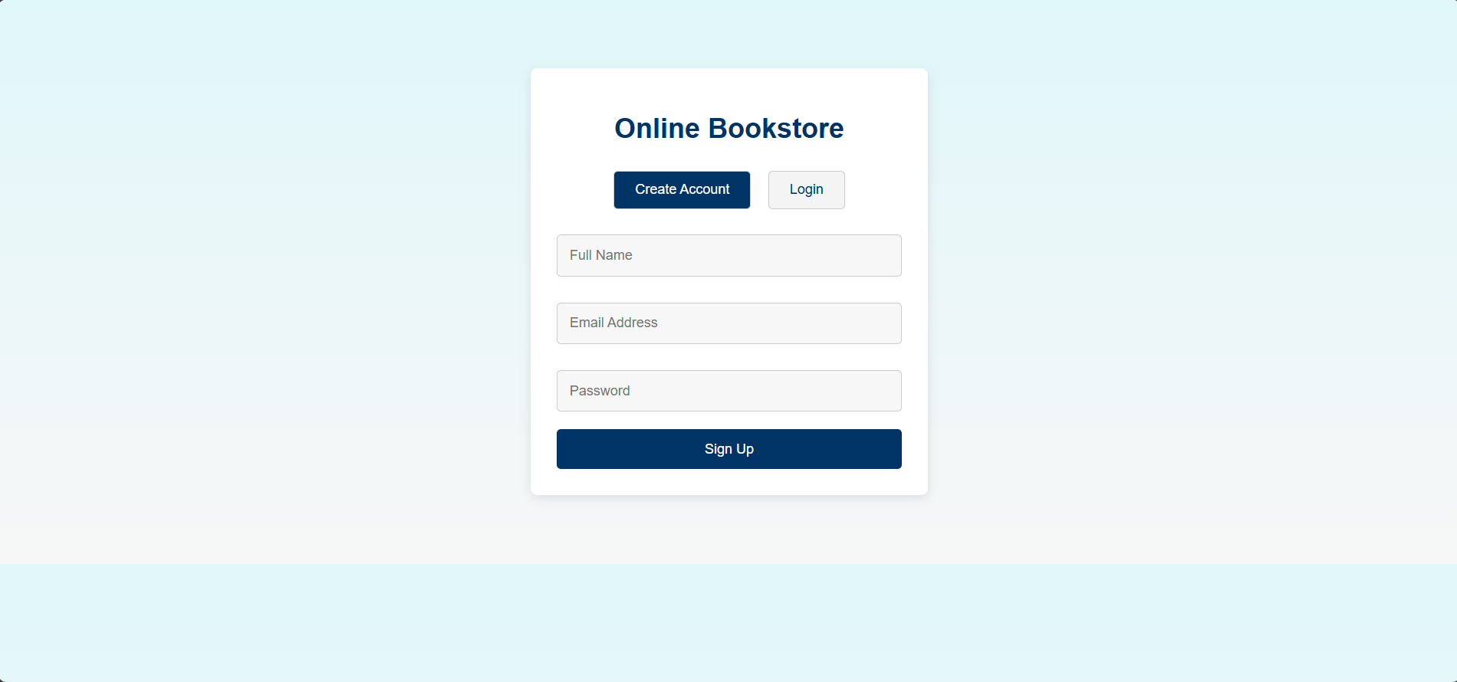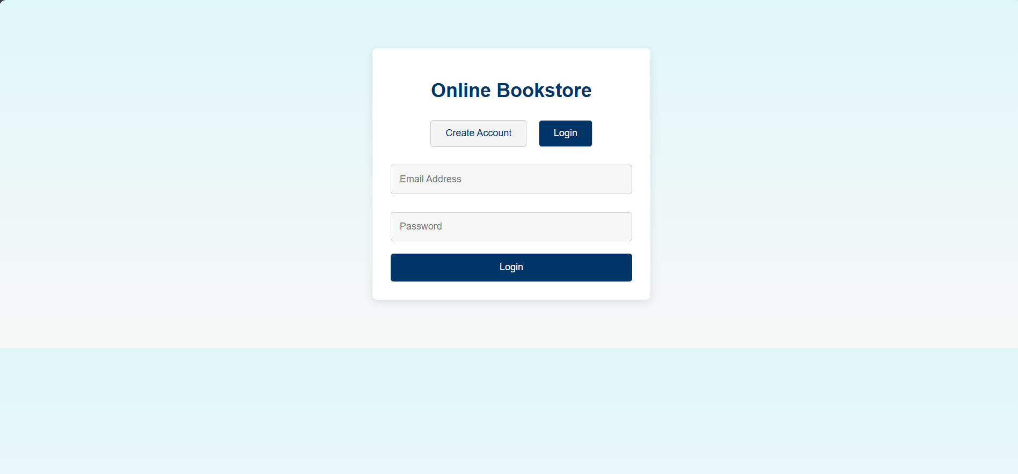

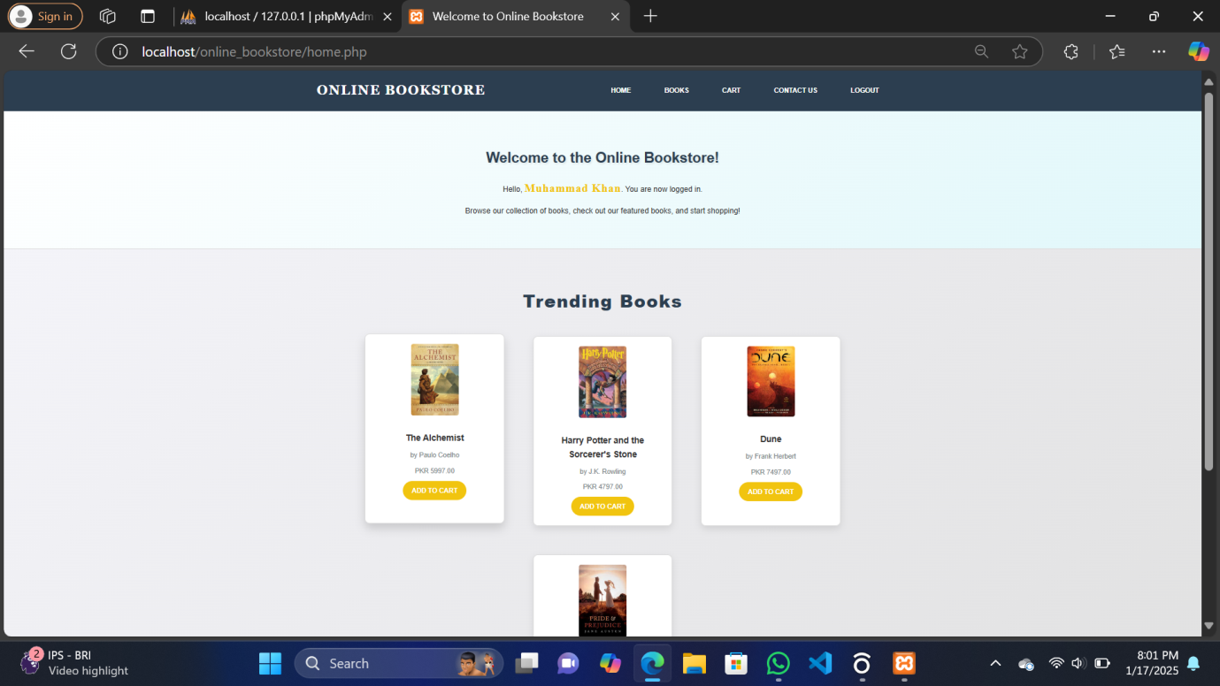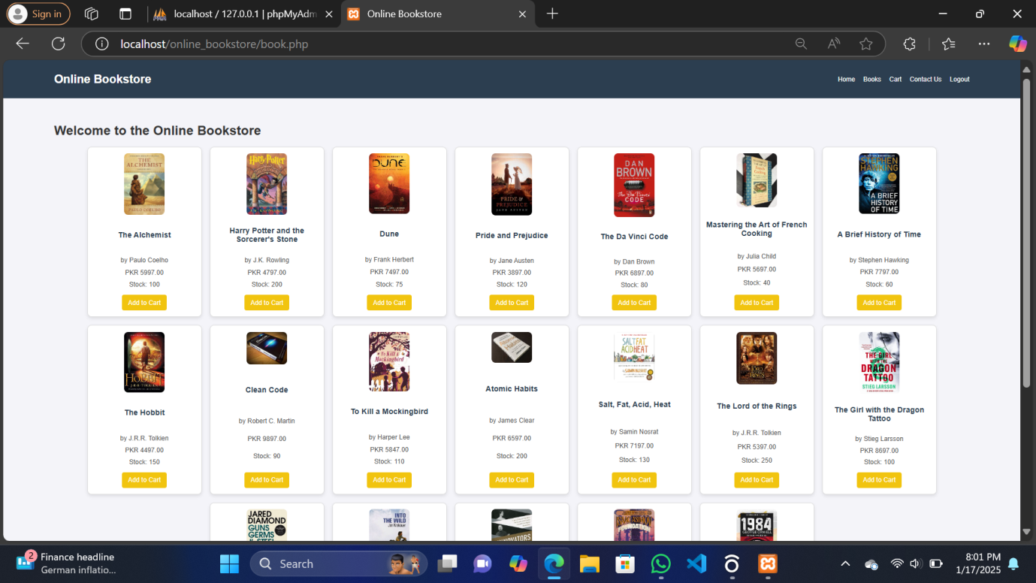

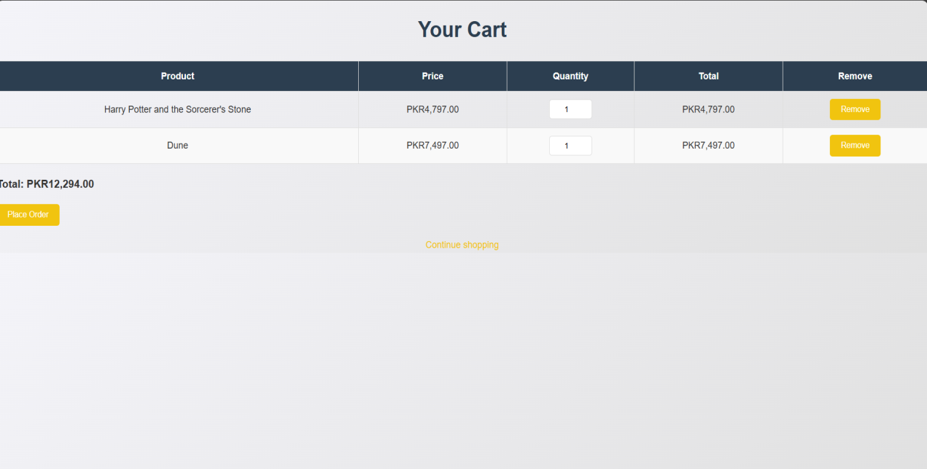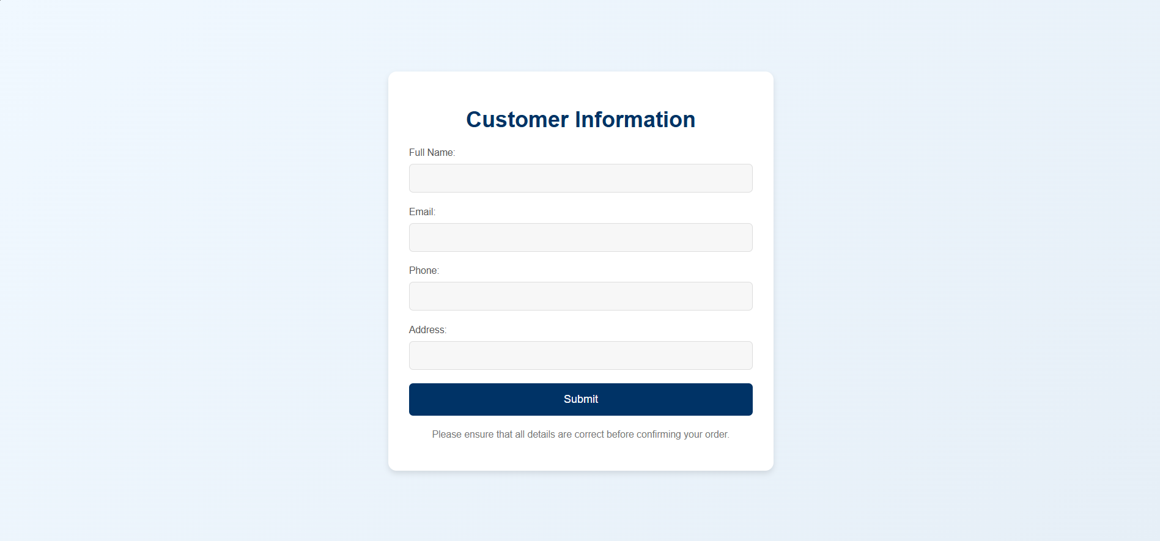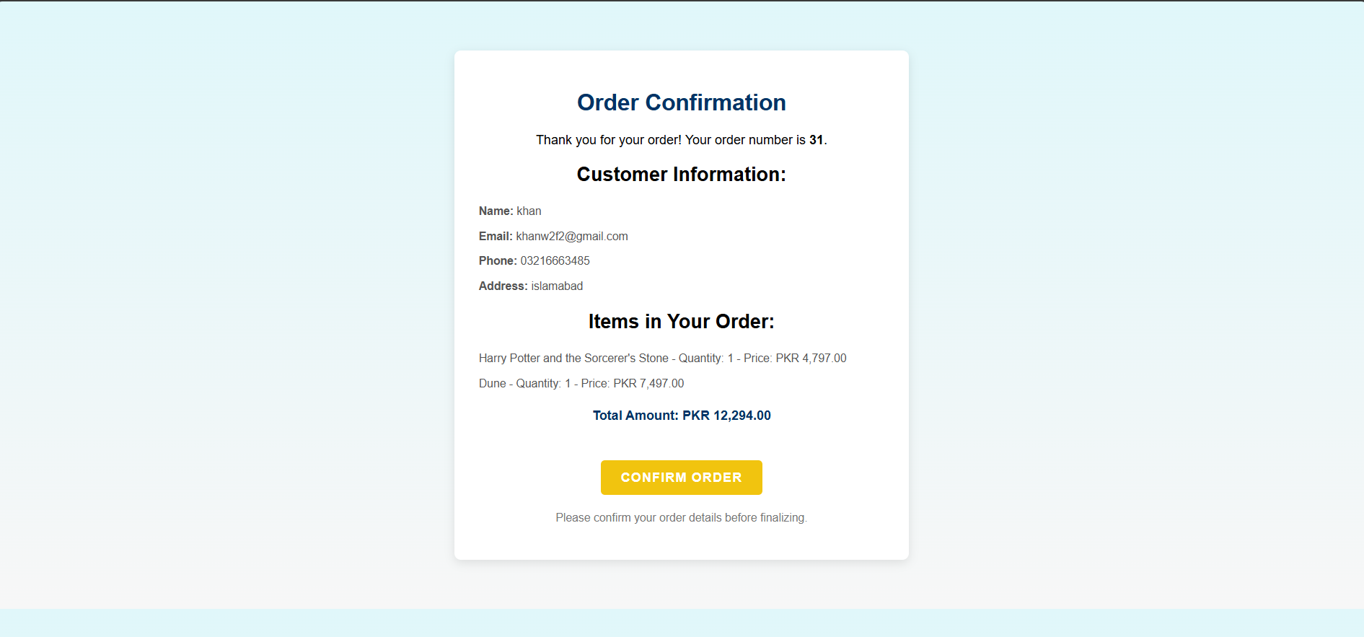Screenshot 2025-01-17 195848.png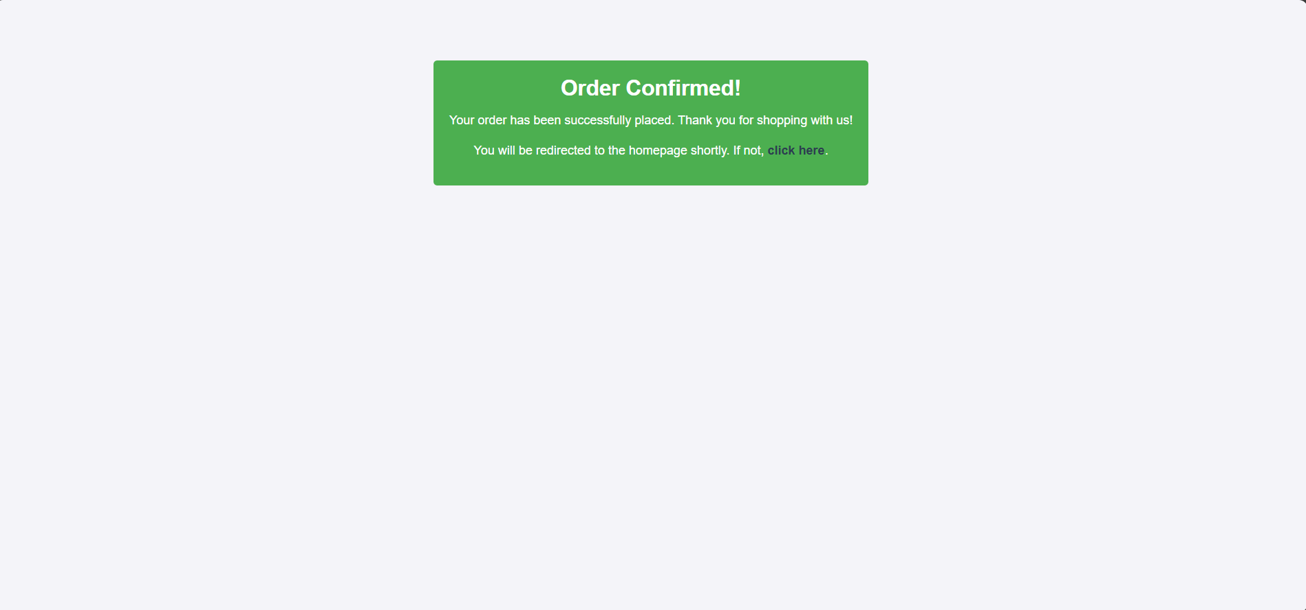

# ****8. Implementation****

### ****Tools Used:****

1. **MySQL:** For database creation and queries.
2. **PHP:** For server-side scripting.
3. **HTML/CSS:** For frontend design.

### ****Steps Taken:****

1. Designed tables and implemented relationships in MySQL.
2. Developed PHP scripts to connect the database to the application.
3. Created the login and registration functionality.
4. Built pages for browsing books and managing the cart.
5. Implemented the order placement and confirmation process.

# ****9. Data Conversion and Loading****

**Data Source:**  
Initial data for books and users were added manually using SQL INSERT statements for testing. The database handling was done using **SQL** commands and the **phpMyAdmin** tool to streamline the management and visualization of data during development.

PHPMYADMIN:

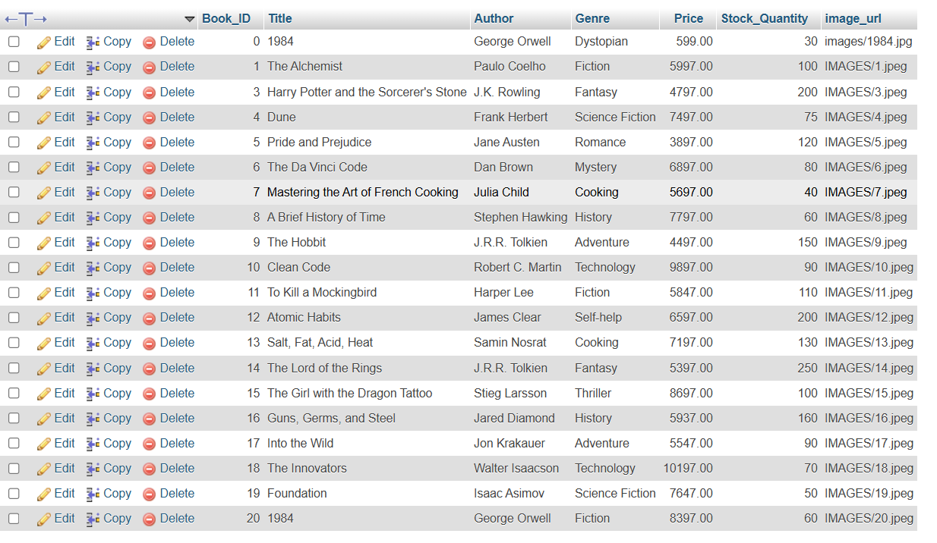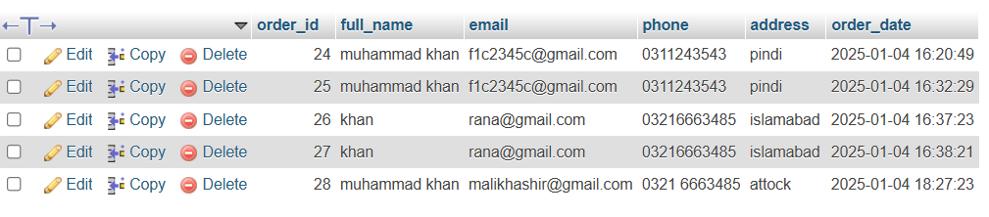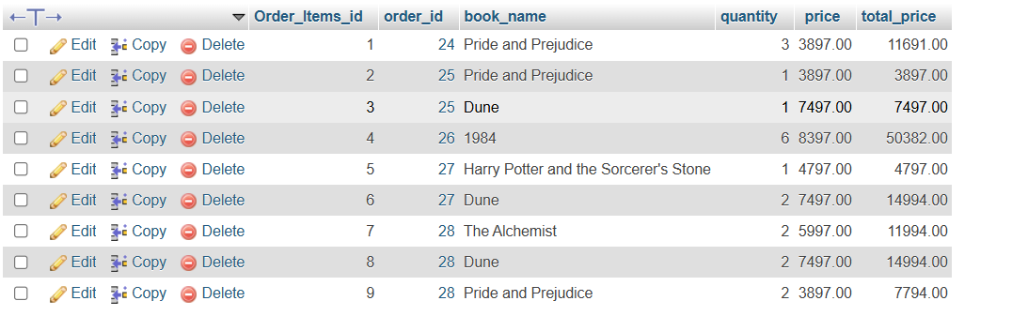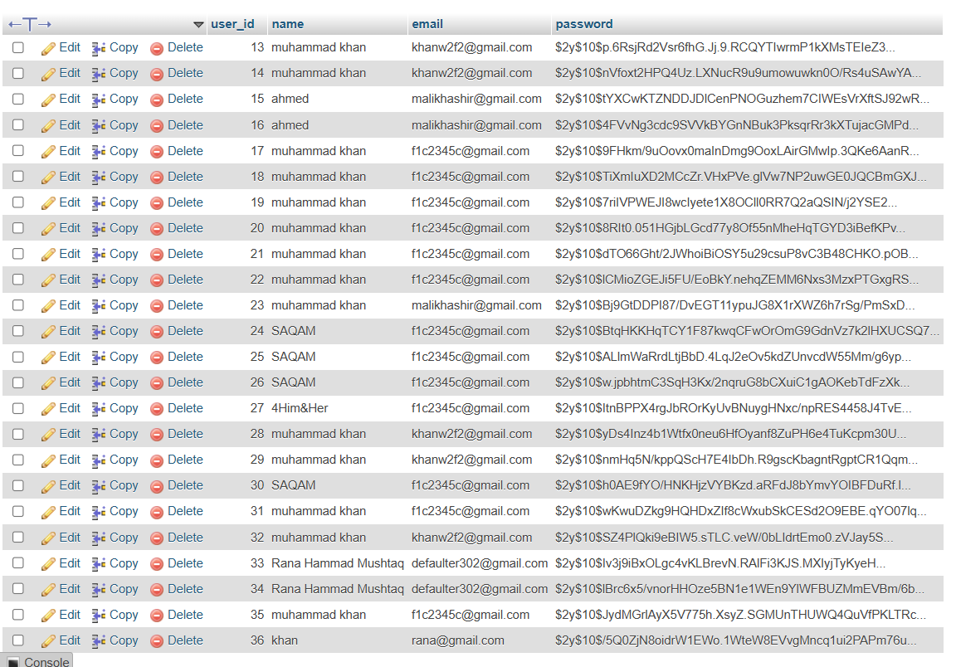

SQL QUERIES:

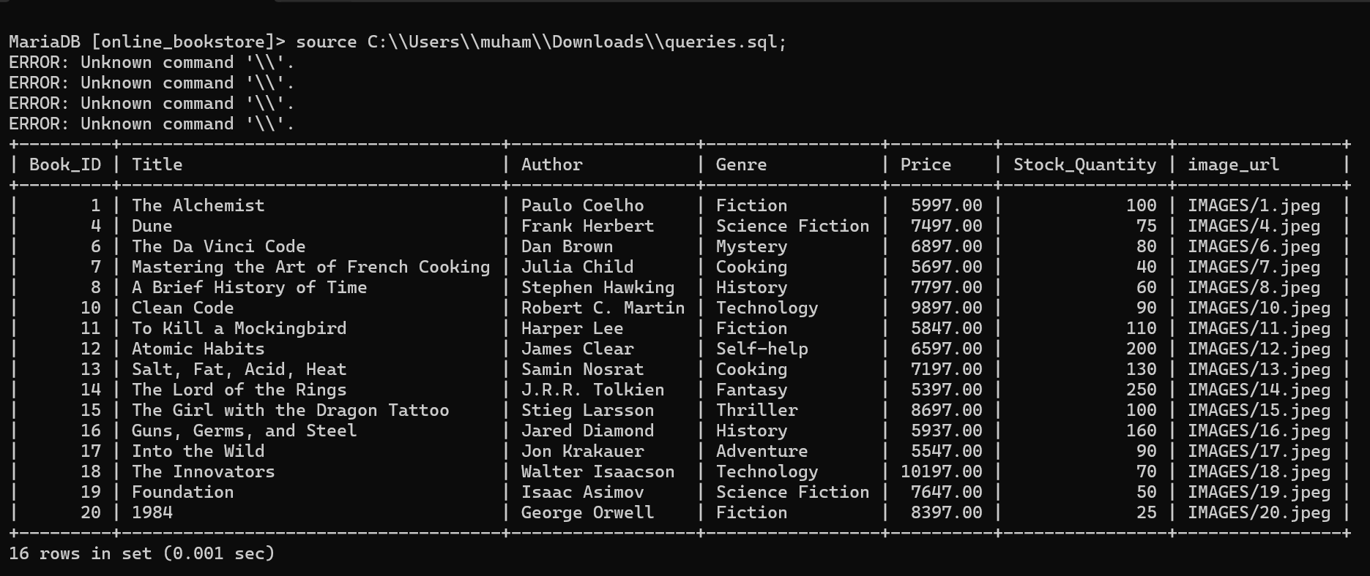

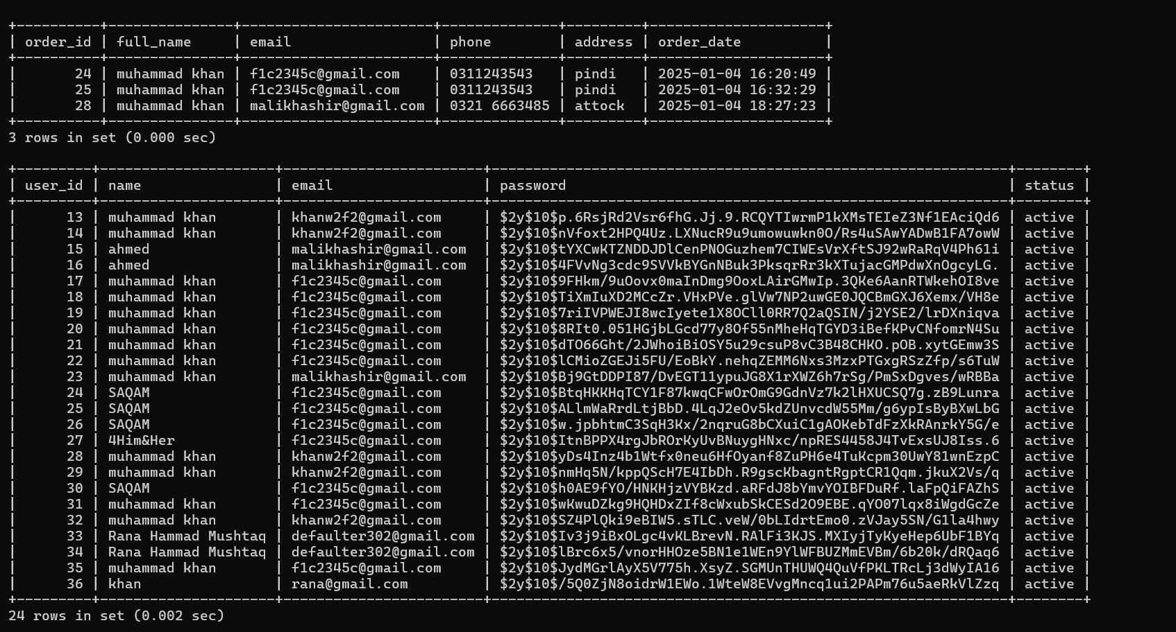

# ****10. Testing****

**Testing Process:**

1. Verified login and registration functionality.
2. Ensured the book page displayed correct details.
3. Tested cart operations (add/remove items).
4. Confirmed orders were stored accurately in the database.

**Results:**  
All features passed functional and integration testing.

# ****11. Operational Maintenance****

**Ongoing Tasks:**

* Update book inventory as needed.
* Monitor for system issues and bugs.
* Regular backups of the database for data safety.
* Establish database recovery procedures to ensure data integrity in case of failure.